Using in Citrix via Android

- Launch the “Play Store”
- Type ‘Citrix’ or ‘Citrix Workspace’ in the search bar in the upper right-hand corner, or under the Search tab, and
select ‘search’

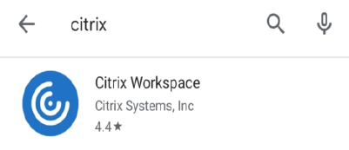
- Select ‘Install’ or the download icon to the right of ‘Citrix Workspace’

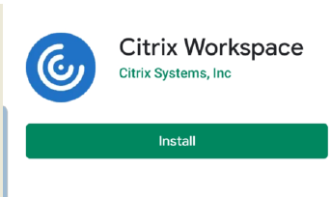
- A blue Workspace icon should appear on your Android once the installation is complete

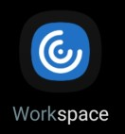

- Select “Workspace” on the desktop

- On the initial screen, select “Get Started”
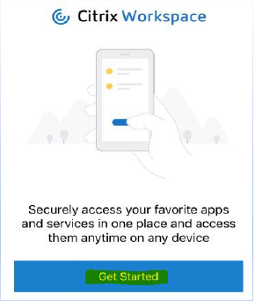
- From the “Welcome” screen, select url box type in - https://demicitrix.etenet.com

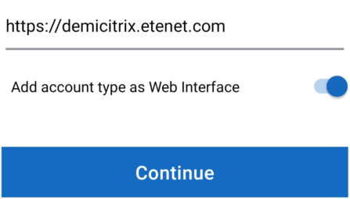

- Select “Select ‘Web Interface’ and now the check mark should move to Web Interface”

9. After you click Continue - Type in your DMC credential

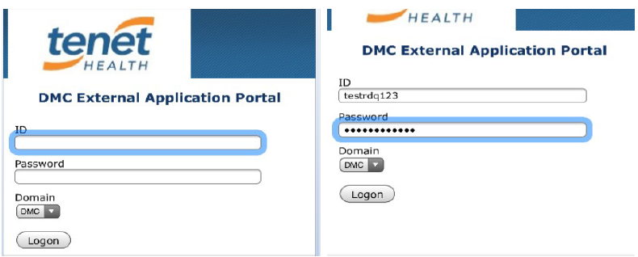

10. Launch one of the apps in your “Favorites” by selecting it from the list OR

11.

Select the three bars in the top left-hand corner, select “ALL APPS”, and then browse through the list of Categories and Applications until you locate the Application you are seeking
NOTE: Select the Search icon in the top right-hand corner to quickly find your applications

